Title. Remarks for Authors

Firstname NAME (Organisation)*
Firstname NAME (Organisation)
Firstname NAME (Organisation)
Firstname NAME (Organisation)

Abstract: max. 500 characters

Key Words: max. 5 key words

Scope of Contributions
The program committee of the Urban Operations Expert Talks welcomes any contribution to the challenges of urban operations to improve the interdisciplinary capabilities for mission accomplishment. The topic for the UOET 23 is “Decision-Making in Urban operations”. Urban operations pose very specific challenges for emergency organizations and operators alike. Urban operations and interdisciplinary capability development must be framed by the three main factors of size, triple-S and complexity (Hofer 2022). The #UOET23 will address the requirements, comprehensive collaboration, and specialized tools for decision-making in this extremely demanding environment as for example the RADIV process:
“RADIV can be defined as a core support process in assisting focused networking within the stakeholder group, rapid integration of heterogenous data, and fostering interoperability between applications and visualization [...]” (Hofer et al. 2022, p. 306)

Submission Procedure
After registration for the conference, an abstract (max. 500 characters) of your paper has to be submitted to thermilak.instowb@bmlv.gv.at until 16th April 2023. Decision upon approval and the detailed program will be available on 20apr23. Afterwards you are invited to submit your paper until 26th June 2022 by uploading it on the ConfTool. The result of the peer-review process should be available within several days to finish your paper.

Formatting: Headings (Garamond, 13pt, bold)
  - Sub-Headings (Garamond, 12pt, underline)
Two different formats are accepted. Short papers in combination with a presentation at the conference. These papers must not exceed 6 pages. Ideally the presentation and the content of the short paper complement each other. A full paper provides a deep inside view into a specific topic, includes around 20 pages and is not linked to a presentation.
Headings: Garamond, 13pt, bold
Sub-Headings: Garamond, 12pt, underlined
Main body: Garamond, 11pt, single-line spacing, justified, add space after paragraph
Citations: Garamond, 11pt, italic, center
Using Citavi with the Word Add-in and citation style „Citavi Default Style“ will enable better collaboration by using the „Urban Operations Expert Talks“ Citavi Cloud for which we can activate you on request after registration. The publication bibliography will also be generated automatically then. You can also add illustrations directly from Citavi as depicted in figure 1.

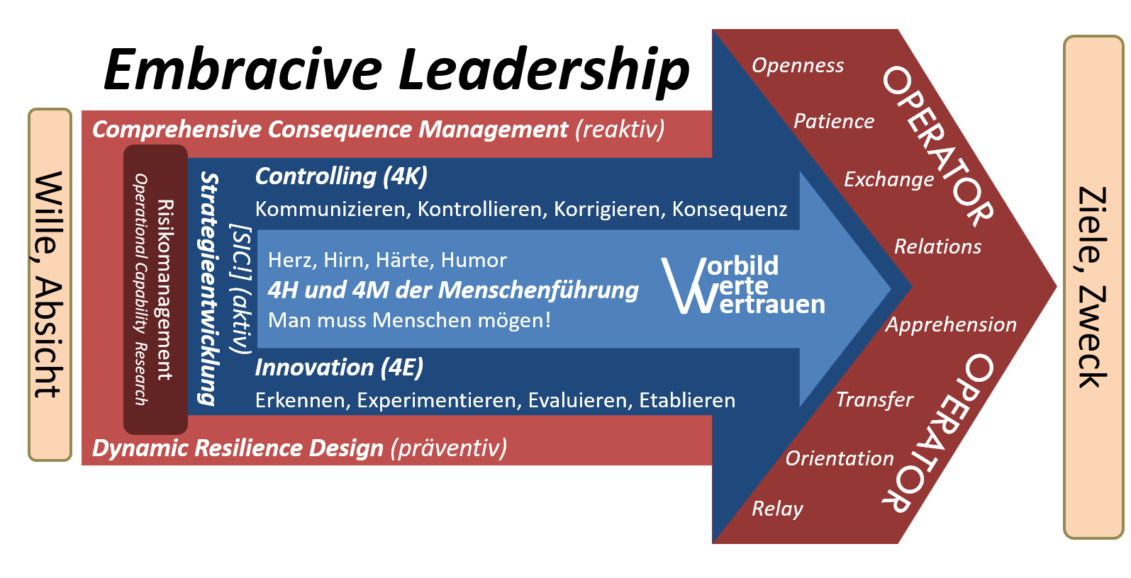
Figure 1: The Embracive Leadership Model has proven to be a useful tool for a wide range of applications. (Hofer 2018, p. 455)

Figures (Figure 1) and tables (Table 1) must be referenced in the text.
Table 1: Tables can also be used in the following format.
Content 1 | Content 2 | Content 3 | Content 4

Publication
All papers fulfilling the standards of the peer-review process will be made available on the conference homepage.

Contact
If you have any questions, please feel free to contact the editors: thermilak.instowb@bmlv.gv.at

Publication bibliography
Hofer, Peter (2022): Improving Urban Operations by Integration. The NIKE Research and Development Program. #UOET22 Meeting Proceedings. Available online at https://www.milak.at/fileadmin/milak/InstOWB/UOET/Meeting_Proceedings/2022_HOFER_Improving_Urban_Operations_by_Integration_pub.pdf, checked on 1/19/2023.
Hofer, Peter; Eder, Julian; Hager, Lukas; Strauß, Clemens; Jacobs, Sebastian (2022): RApid Data Integration and Visualization (RADIV) in Subsurface Operations. In Geomechanics and Tunnelling 15 (3), pp. 305–310. DOI: 10.1002/geot.202100068.

Indirect quotation.
Direct quotation.
https://uoet.unileoben.ac.at [15/02/23]
20 minutes of presentation followed by 10 minutes discussion.
https://www.milak.at/nike/ueot [15/02/23]

